UNCANNY VALLEY 7

1. What do these three people have in common

* Ernst Jentsch
* Sigmund Freud
* Masahiro Mori
* **They have all addressed the creepy effects of highly humanlike machines**

1. “On the psychology of the uncanny” – Jentsch

* entsch describes uncanny feelings as “intellectual uncertainty” and not being “at home” in the situation concerned

1. “The uncanny” - Freud

* Freud emphasized that what is uncanny is something that seems to be “un-homely” and unfamiliar, but at the same time “homely” and familiar
* In Freud’s view, the uncanny might be anything we experience in adulthood that reminds us of early psychological stages or of primitive experiences
* **Freud names the concept of the uncanny doppelgänger**

1. The Uncanny Valley – Mori

* as robots become more humanlike, they appear more familiar until a point is reached at which subtle imperfections of appearance make them look eerie
* This led Mori to the belief that robot builders should not attempt to make their creations overly lifelike and realistic in appearance
* 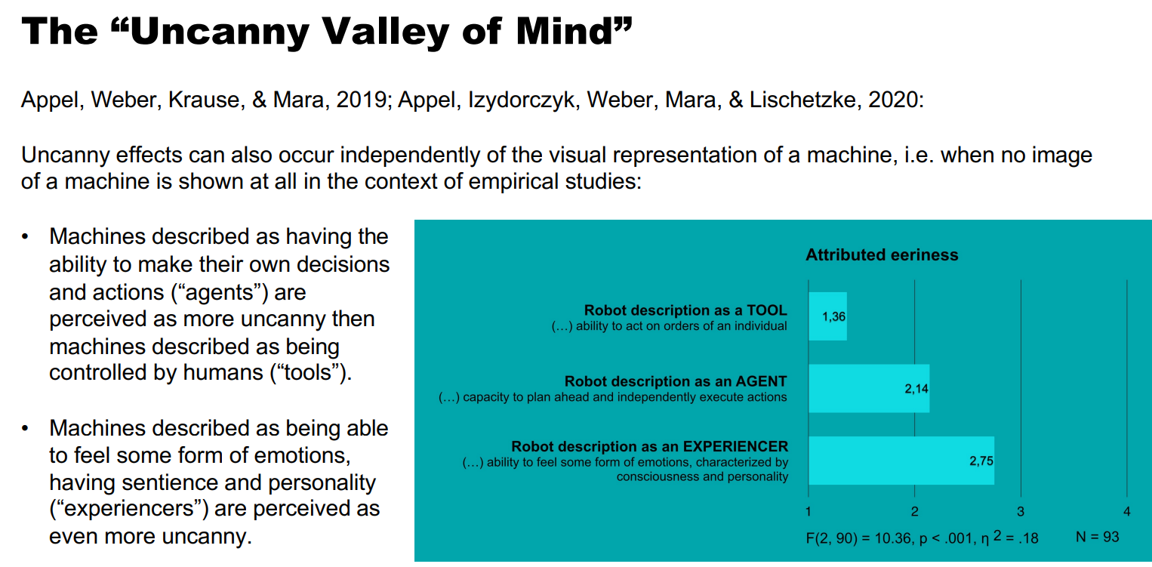general assumption that highly lifelike robots/machines are often experienced as eerie